Name: **Adiba Anbar Ahona**

ID: **19101257**

Section: **3**

**LAB Assignment 1**

**TASK 1.1: Drawing Pixel**

from OpenGL.GL import *  
from OpenGL.GLUT import *  
from OpenGL.GLU import *  
import random  
  
x = random.sample(range(100,300),50)  
y = random.sample(range(100,300),50)  
  
def draw_pixel():  
 glPointSize(5)  
 glBegin(GL_POINTS)  
 for i in range(50):  
 glVertex2f(x[i], y[i])   
 glEnd()  
  
def iterate():  
 glViewport(0, 0, 500, 500)  
 glMatrixMode(GL_PROJECTION)  
 glLoadIdentity()  
 glOrtho(0.0, 500, 0.0, 500, 0.0, 1.0)  
 glMatrixMode (GL_MODELVIEW)  
 glLoadIdentity()

def showScreen():  
 glClear(GL_COLOR_BUFFER_BIT | GL_DEPTH_BUFFER_BIT)  
 glLoadIdentity()  
 iterate()  
 glColor3f(1.0, 1.0, 1.0) #konokichur color set (RGB)  
 #call the draw methods here  
 draw_pixel()  
 glutSwapBuffers()  
  
glutInit()  
glutInitDisplayMode(GLUT_RGBA)  
glutInitWindowSize(500, 500) #window size  
glutInitWindowPosition(0, 0)  
wind = glutCreateWindow(b"19101257_Drawing pixel") #window name  
glutDisplayFunc(showScreen)  
  
glutMainLoop()

**output:**

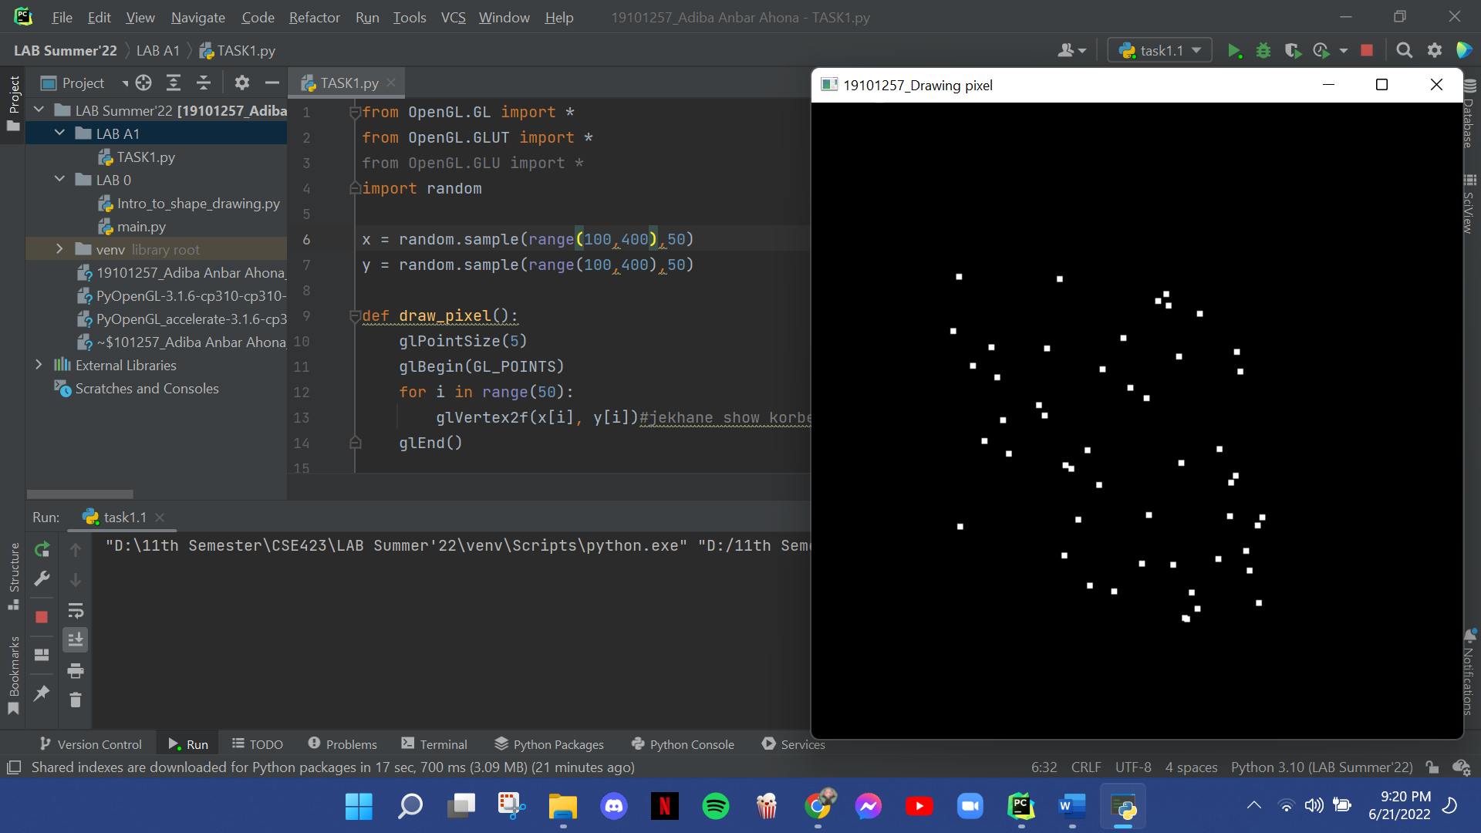

**Task 1.2: Drawing A House**

from OpenGL.GL import *  
from OpenGL.GLUT import *  
from OpenGL.GLU import *  
  
def draw_lines():  
 glLineWidth(4)  
 glEnable(GL_LINE_SMOOTH)  
 glBegin(GL_LINES)

# triangle/roof  
 glColor3f(81.0/255, 8.0/255, 16.0/255)  
 glVertex2f(200, 500)  
 glVertex2f(100, 400)  
 glVertex2f(300, 400)  
 glVertex2f(200, 500)

# House body  
 glColor3f(245.0/255, 83.0/255, 181.0/255)  
 glVertex2f(100, 400)  
 glVertex2f(100, 200)  
  
 glVertex2f(100, 200)  
 glVertex2f(300, 200)  
  
 glVertex2f(300, 200)  
 glVertex2f(300, 400)  
  
 glVertex2f(300, 400)  
 glVertex2f(100, 400)

# window1  
 glColor3f(66.0/255, 248.0/255, 240.0/255)  
 glVertex2f(120, 370)  
 glVertex2f(120, 330)  
 glVertex2f(120, 330)  
 glVertex2f(160, 330)  
 glVertex2f(160, 330)  
 glVertex2f(160, 370)  
 glVertex2f(160, 370)  
 glVertex2f(120, 370)  
  
 # window2  
 glVertex2f(240, 370)  
 glVertex2f(240, 330)  
 glVertex2f(240, 330)  
 glVertex2f(280, 330)  
 glVertex2f(280, 330)  
 glVertex2f(280, 370)  
 glVertex2f(280, 370)  
 glVertex2f(240, 370)  
  
 #door  
 glColor3f(255.0/255, 253.0/255, 83.0/255)  
 glVertex2f(170, 200)  
 glVertex2f(170, 300)  
 glVertex2f(170, 300)  
 glVertex2f(230, 300)  
 glVertex2f(230, 300)  
 glVertex2f(230, 200)  
 glVertex2f(230, 200)  
 glVertex2f(170, 200)  
 glEnd()  
  
 #doorknob  
 glPointSize(7)  
 glEnable(GL_POINT_SMOOTH)  
 glBegin(GL_POINTS)  
 glColor3f(238.0/255, 149.0/255, 61.0/255)  
 glVertex2f(220.0, 250.0)  
 glEnd()  
  
def iterate():  
 glViewport(0, 0, 500, 500)  
 glMatrixMode(GL_PROJECTION)  
 glLoadIdentity()  
 glOrtho(0.0, 500, 0.0, 500, 0.0, 1.0)  
 glMatrixMode (GL_MODELVIEW)  
 glLoadIdentity()  
  
def showScreen():  
 glClear(GL_COLOR_BUFFER_BIT | GL_DEPTH_BUFFER_BIT)  
 glLoadIdentity()  
 iterate()  
 glColor3f(0.0, 5.0, 3.0) #konokichur color set (RGB)  
 #call the draw methods here  
 draw_lines()  
 glutSwapBuffers()  
  
glutInit()  
glutInitDisplayMode(GLUT_RGBA)  
glutInitWindowSize(500, 570) #window size  
glutInitWindowPosition(0, 0)  
wind = glutCreateWindow(b"Task 2: A House") #window name  
glutDisplayFunc(showScreen)  
  
glutMainLoop()

**Output:**

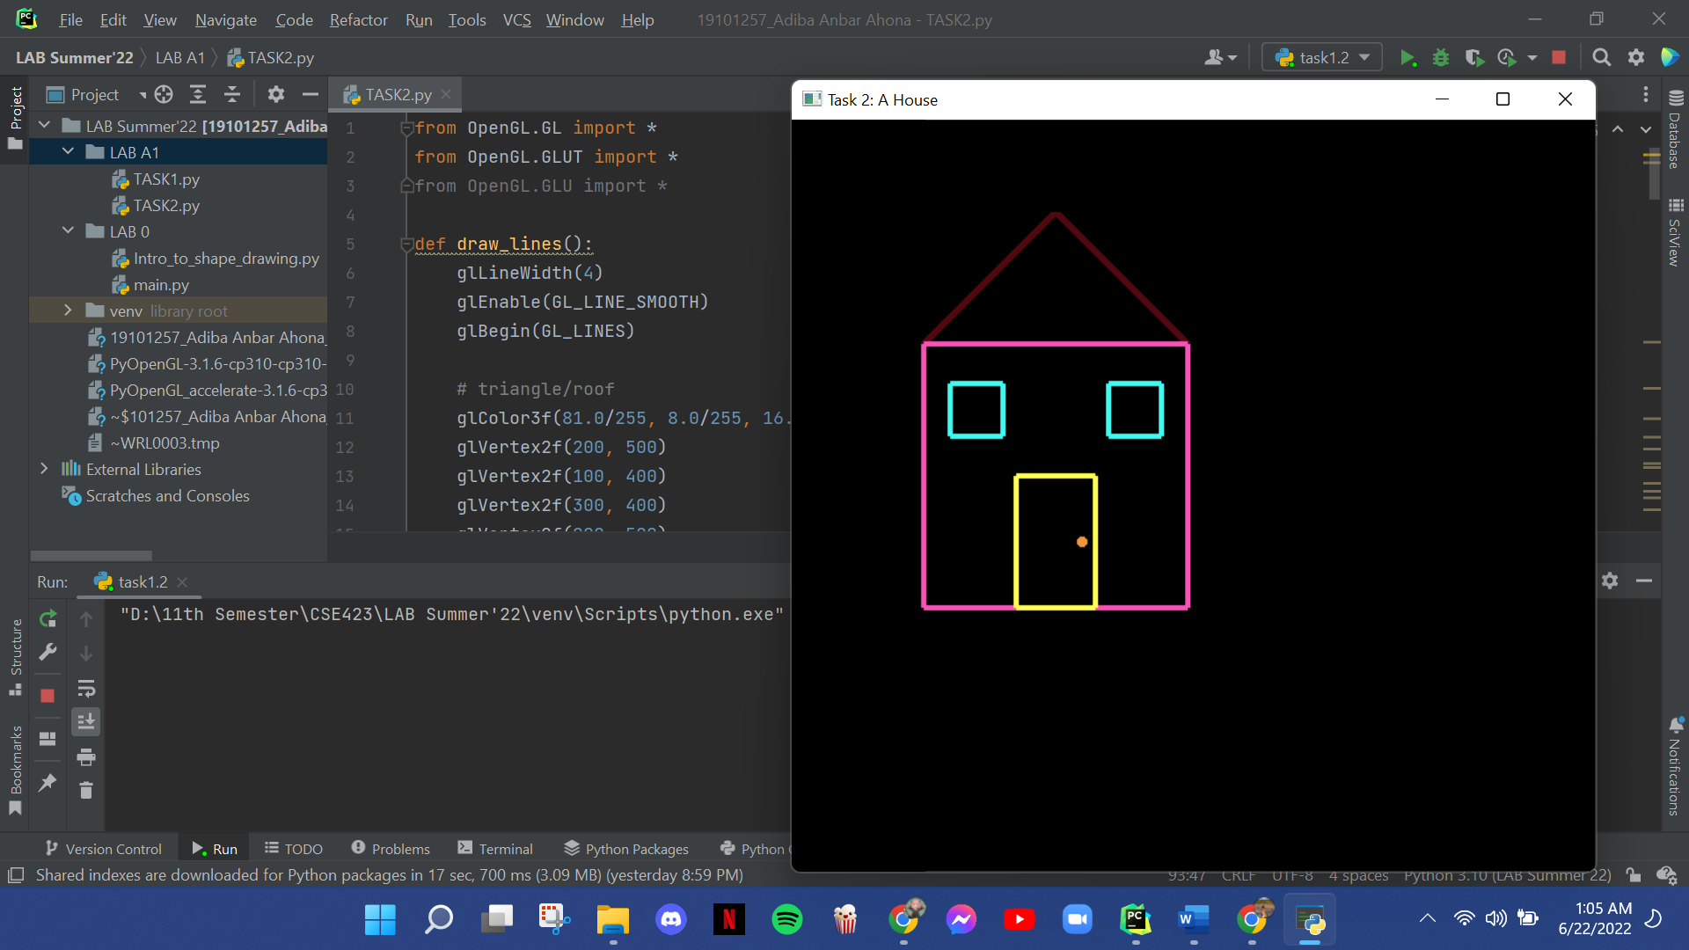

**Close picture of the outputs:**

